2018-kjL-Simple Tutorial to add extension into Apple Policy Whitelist for Mac

# Intial: APR08(SUN) 19:45 Final: APR08(SUN) 20:06

System: 10.13.4

Chrome Version: 65.0.3325.181 (Official Build) (64-bit)

Extension Version: v2.0(maybe)

ID: phmcfomifkfaochjgpnilemkplkbblon

1. Download All the stuffs you need from my Github Branch(site: https://github.com/prenfic/high-speed-downloader) or Official Github

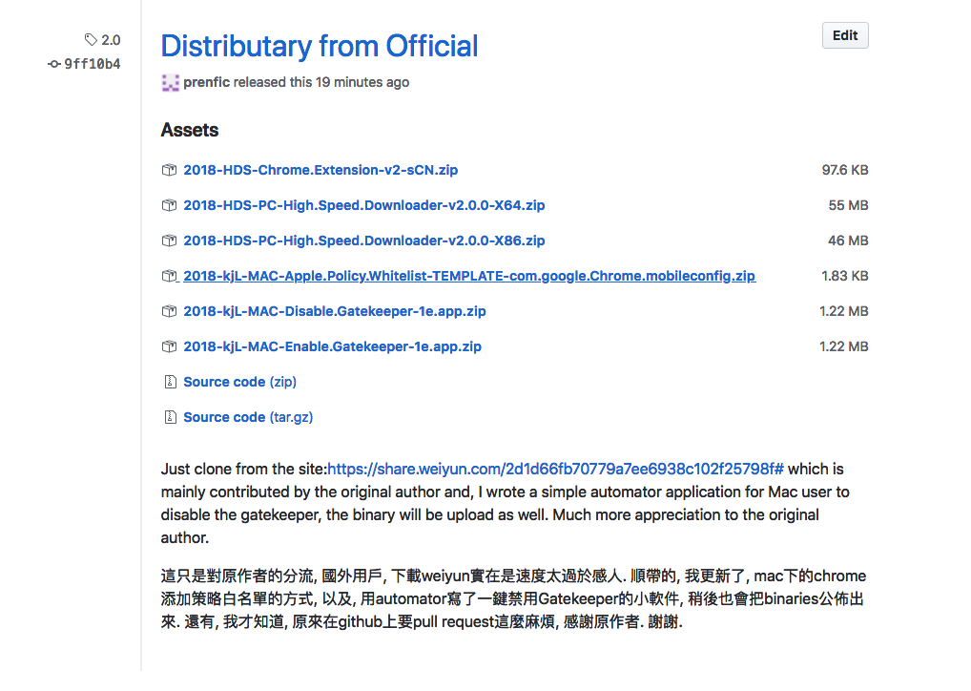

1. Open your chrome, and mine version is, v65
2. Key-in the chrome://extensions/ or open the extensions page

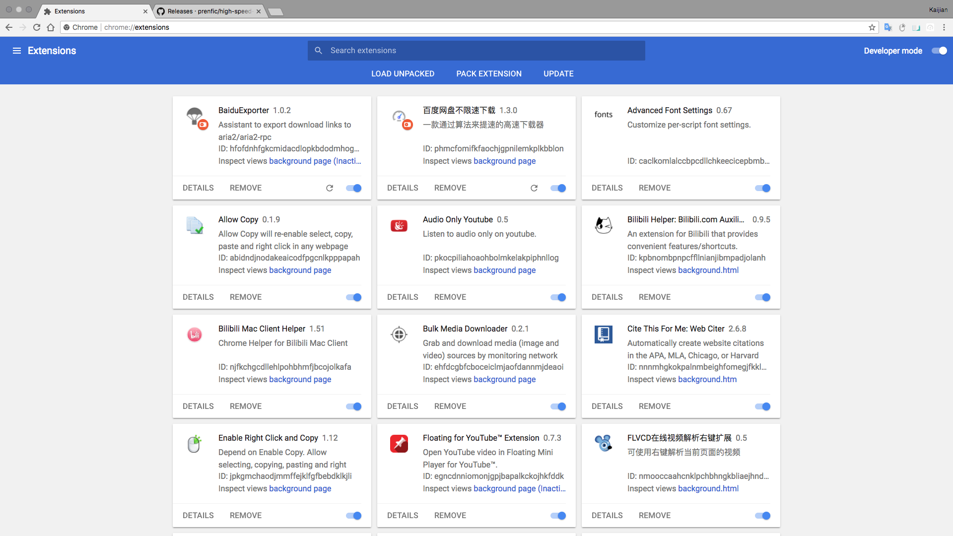

1. Open the Developer Mode and mine is at the right-upper corner



1. Press at the buttion, “Load Unpacked”
2. Locate to the extensions where you downloaded and unzipped, and mine is at the /Application where I suggest to put at, and click on the button, “Select”

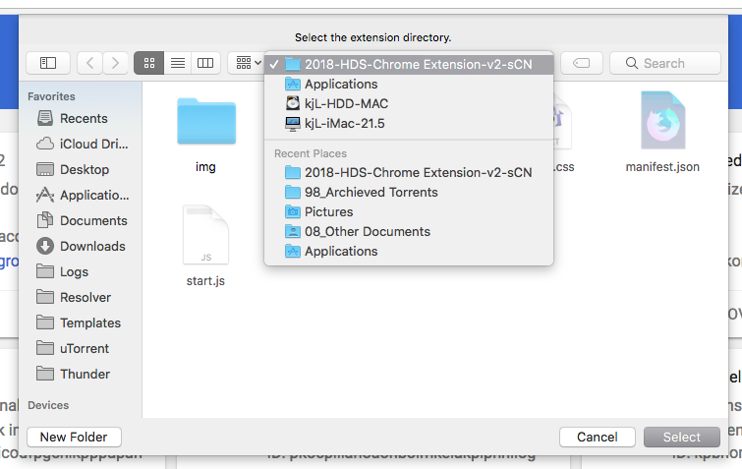

1. There it is and you would notice that, there is an “id”, copy it.

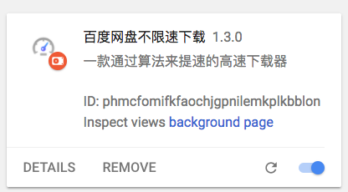

1. Open the .mobileconfig you downloaded by Text Editor, (BBEdit maybe), and locate to the line no. 19, 20 and 21.

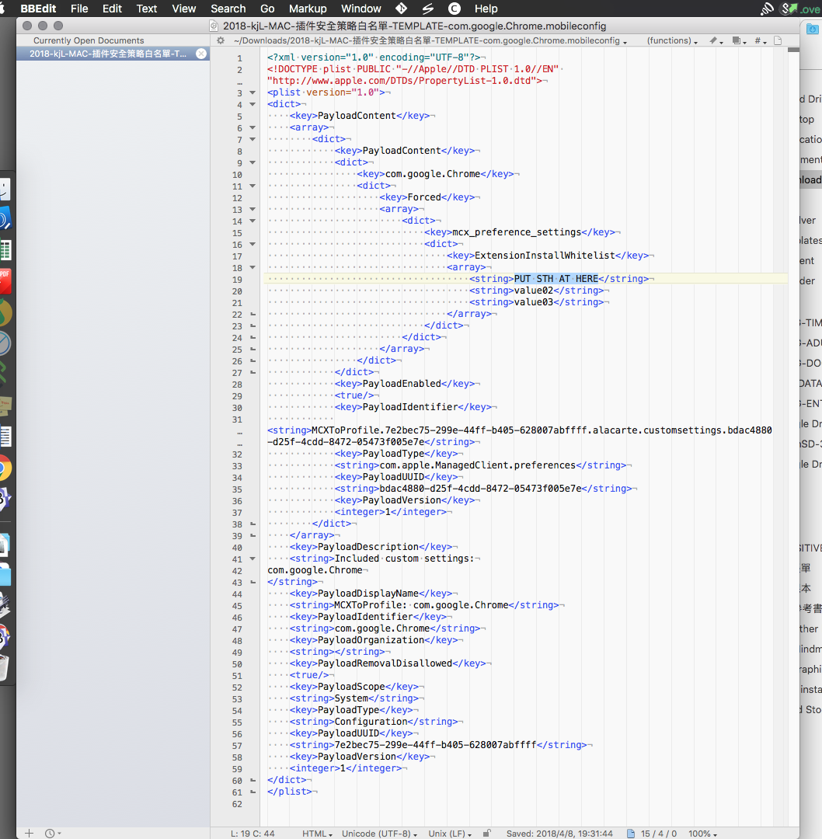

1. Paste your id there and, click on save and then run it.
2. THAT’s ALL.